28.33: Consider a coaxial cable where the currents run in the SAME direction.
a) For 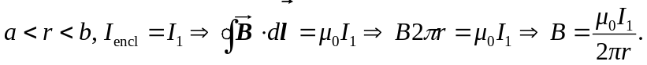
b) For

